Welcome to Northwestern Women’s Health Associates for your prenatal care.
Phone: (312) 440-9400 Fax: (312) 440-0423
Genetic Screening Options

We deliver at Prentice Women’s Hospital: 250 E. Superior St. Chicago IL 60611. (312) 472-0800.

GENETIC CARRIER SCREENING
Healthy people can still be carriers for genetic diseases that can be passed on to your baby. Over 80% of babies born with genetic diseases have no known family history.
- Selective screening: we will recommend tests based on your family’s history and countries of origin.
- Universal screening (Family Prep Screen): check your carrier status of over 100 diseases.
______________________________________________________________________________
DOWN SYNDROME TESTING
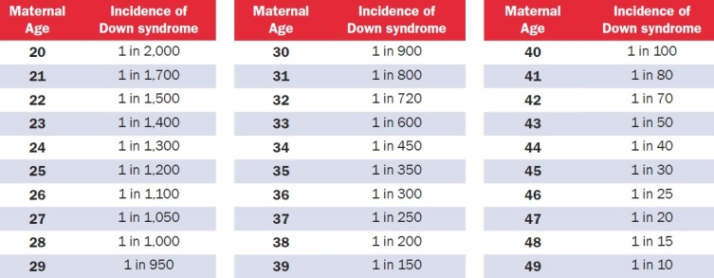
- Combined first and second trimester (stepwise) tests: this stepwise test combines the results of bloodwork taken at 12 weeks and 16 weeks, as well as an ultrasound done at 12 weeks. A preliminary result is given after the 12-week tests are done. This test detects 85% of Down syndrome pregnancies.
- Ariosa’s “Harmony” Cell-free DNA test: this screening test analyzes fragments of the baby’s DNA that reach your bloodstream. This test is usually covered by insurance for women age 35+ because they have the highest individual risk for a child with Down Syndrome. Done as early as 10-12 weeks. This test detects over 99% of Down syndrome pregnancies, and can also identify gender.

- Chorionic villus sampling (CVS): the baby’s DNA is directly analyzed by sampling the placenta, using a very thin needle through the belly or vagina. Done after 10 weeks of pregnancy. This test is considered invasive and has a very low miscarriage risk.
- Amniocentesis: the baby’s DNA is directly analyzed by sampling the fluid around the baby, using a very thin needle through the belly. Done after 15 weeks of pregnancy. This test is considered invasive and has a very low miscarriage risk.

